|  |
| --- |
| PS2Win |
| Weekly Report |
| Keep Your Time |

|  |
| --- |
| Filipe Brandão  26-05-2013 |

**Team Members:**

Carla Machado

David João

Filipe Brandão

João Girão

João Martins

Mário Oliveira

Rui Ganhoto

**Week 14**, 20th of April to 27th of May

Content

1. Week Activities 1

1.1. Work Executed 1

1.2. Work Analyses 1

1.3. Achievements 1

2. Impediments 1

3. Plans For Next Week 1

4. Progress 2

4.1. Earned value and/or Gantt Image 2

4.2. Effort by task 3

4.3. Individual effort 3

5. Individual log 4

**Images**

Figure 1: Earned Value 2

Figure 2: Week effort by task type 3

Figure 3: Week effort by team member 3

**Tables**

Table 1: List of Contributors ii

Table 2: Version history ii

Table 3: Log of individual effort 4

|  |  |  |  |
| --- | --- | --- | --- |
| **Authors and Contributors** | | | |
| **Date** | **Name** | **Contacts** | **Contribution** |
| 26-05-2013 | Filipe Brandão | a21180276@alunos.isec.pt | Author |
| 26-05-2013 | Mário Oliveira | a21170292@alunos.isec.pt | Contributor |
|  |  |  |  |

Table 1: List of Contributors

|  |  |  |  |  |  |
| --- | --- | --- | --- | --- | --- |
| **Revision History** | | | | | |
| **Date** | **Description** | **Author** | **Version** | **Approvers** | **State** |
| 26-05-2013 | Creation of first draft | Filipe Brandão | 0.1 |  | Draft |
| 26-05-2013 | Changing state | Filipe Brandão | 0.1 |  | Ready for Revision |
| 26-05-2013 | Document reviewed | Mário Oliveira | 0.1 |  | Ready for Revision |
| 27-05-2013 | Minor correction | Filipe Brandão | 0.2 |  | Ready for Revision |
| 27-05-2013 | Changing State | Filipe Brandão | 0.2 |  | Ready for Approval |

Table 2: Version history

# Week Activities

# Work Executed

* Code Inspection - Meeting and rework
* Test Plan corrected and reviewed again
* Finished “Task Details” coding task
* Finished “Inactivity Alerts – detection” coding task
* Finished “Export app data” coding task

# Work Analyses

There were no reports of lateness but at the end of the week there are some tasks unfinished. Also, the Test Plan is not approved and it is expected to execute it next week. In the next week, the team needs to start working as soon as possible to get all the functionality ready for testing and correction.

One member reported, once again, that the lack of knowledge about the framework affected his performance.

# Achievements

* Database module was inspected

# Impediments

The continuous rework on the Test Plan is unbearable. 13 effort hours were expected for that task but it now reached 44 hours and should finished long time ago. This is affecting the project because it was planned that, at the moment, the resources should be doing other tasks and the Test Plan is needed for the next week.

# Plans For Next Week

* Finish the Code Inspection (Follow-up)
* Finish all the coding tasks
* Execute Test Plan (and fix defects found) including usability tests

# Progress

# Earned value and/or Gantt Image

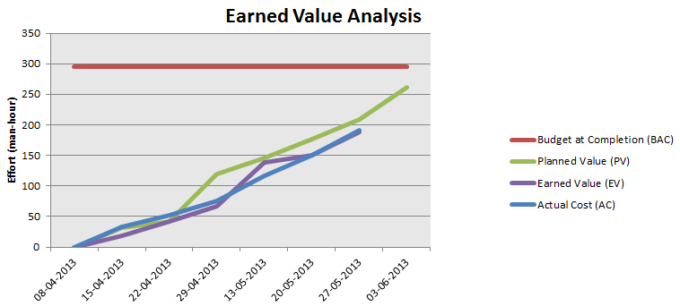

Figure 1: Earned Value

Planned Value = 209h

Earned Value = 188h

Actual Cost = 191h

Although the SPI value is not critical (approximately 0.9), the Schedule Variance (-21) plus the planned effort for the next week reveals that we have 74h of effort for the last week. This means that each member will have to work more than 10h. A decision must be taken.

Note: the EV graph from the previous Weekly Report was missing the last week values.

# Effort by task

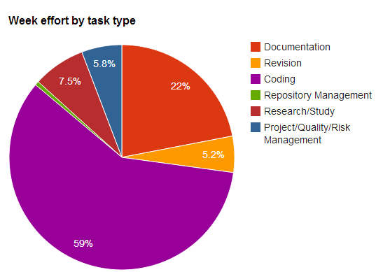

Figure 2: Week effort by task type

# Individual effort

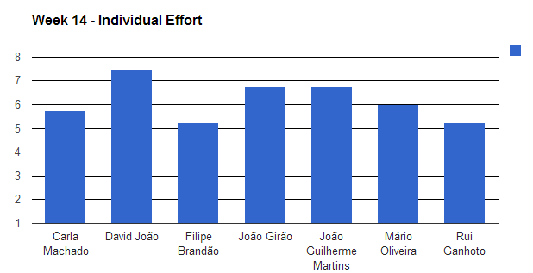

Figure 3: Week effort by team member

|  |  |
| --- | --- |
| **Name** | **Effort(hours)** |
| Carla Machado | 5.75 |
| David João | 7.5 |
| Filipe Brandão | 5.25 |
| João Girão | 6.75 |
| João Guilherme Martins | 6.75 |
| Mário Oliveira | 6 |
| Rui Ganhoto | 5.25 |

Table 3: Log of individual effort

# Individual log

**Carla Machado - Tasks done:**

* Approval of weekly report week 11 0.25h
* Research about WPF objects and implementation (DateTimePicker) 0.25h
* Continuation of the implementation of the functionality Edit Task 0.75h
* Meeting minute review 0.25h
* Continuation of the implementation of the functionality Edit Task 0.5h
* Research icons for the application buttons 1h
* Continuation of the implementation of the functionality Edit Task 1.5h
* Quality tasks - verification of document management procedures and document measures 1h
* Approval of Project Planning Process and SDP 0.25h

**David João - Tasks done:**

* Rewrite of acceptance tests steps and results 2.75 h
* UI and some functionality of shortcut settings 0.75h
* Reordering, formatting, changing diagrams of test plan and update to EA 3.25h
* More functionalities of shortcut settings 0.75h

**Filipe Brandão - Tasks done:**

* Export to CSV 1.25h
* Export to CSV 1.5h
* Export to CSV 1h
* Meeting Minute 0.5h
* Updated Dashboard -> Added Review Measures 0.5h
* Weekly Report 0.5h

**João Girão - Tasks done:**

* Preparation Code inspection 0.5h
* Developing task details 0.75h
* Developing task details 1h
* Developing Inactivity reaction and change inactivity task window UI 3h
* Research hooks 0.5h
* Developing Inactivity reaction 1h

**João Martins – Tasks done:**

**Mário Oliveira - Tasks done:**

* Revision weekly report - Week 11 0.25h
* Upadate repository 0.25h
* Show task listing functionality 0.5h
* Show task listing functionality 3.5h
* Revision Test Plan 1.5h

**Rui Ganhoto - Tasks done:**

* Database Rework (After Inspection) 1.25h
* Inactivity TIme Funcionality 0.75h
* Start/Stop task and Count Task Time Funcionality 0.75h
* Editing Task UI 0.75h
* Editing Task Funcionality 1.5h
* Project Planing Process and Software Development Plan Aproval 0.25h